ICT Engineering

**SEP1Y**

**Process Report**

Submitted to:

Steffen Vissing Andersen

Birgitte von FyrenBalsløv

Prepared by:

Sebastian-Dan Basca

Martin Kostadinov

Octavian Grozman

Mihai Timotin

Submitted on : INSERT DATE HERE



**Contents**

1. Group policy

2. SWOT Analysis

2.1. Group SWOT Analysis

2.2. Individual SWOT Analysis

3. Considerations

4. Daily Project Log

5. Task Log

6. Meeting reports

7. Bloom’ forms

**Group Policy**

The following group rules were established and approved by the entire group before starting working on the semester project.

* Always contact all group members when we are going to miss a meeting.
* Work on group assignments collaboratively and cohesively.
* Switch roles for each assignment.
* Show up on time at meetings.
* All members are notified about the future meetings within at least 12 hour notice.
* Complete the assignments during group meetings (in case we do not manage to complete the tasks during the meetings, we should finish everything at home).
* Assist other members when they encounter problems with their assignment.
* Show interest and passion for the project and be serious as much as possible.
* Communicate in English only.
* Communication between members can be done through Facebook group and also on Skype.
* Take into consideration everyone’s opinion.
* Be open-minded to new suggestions.
* Prioritize SEP over other activities in your schedule.
* Do not disrespect other members of the group, try to behave professionally.
* There will be a weekly discussion about the progress of the project.
* All members will have something to work on.

**SWOT Analysis**

1. Group SWOT Analysis:

**Strengths:** Enthusiasm, positive group members, motivation to succeed, hard-working, good team chemistry, open-minded members

**Weaknesses**: Little experience with group projects, many contradicting opinions, limited creativity, easily distracted.

**Opportunities**: Improve programming and team working skills (proper communication), learn to take responsibility, learn to pay more attention to details.

**Threats**: Splitting the amount of work properly, time management issues (setting up team meetings).

1. Individual SWOT Analysis:

**Martin Kostadinov:**

**Strengths**: Motivated to succeed, positive behavior, practical, reliable.

**Weaknesses**: Easily stressed, selfish, worrying about small details.

**Opportunities**: Develop teamworking and social skills, learn more about programming, get a lot of practical experience.

**Threats**: No specific threats.

**Mihai Timotin:**

**Strengths**: Punctual, creative, optimistic.

**Weaknesses**: Easily distracted and bored.

**Opportunities**: Getting experience in group programming, expand IT knowledge, learning to work in a team environment.

**Threats**: No specific threats.

**Octavian Grozman:**

**Strengths**: Experienced in programming, good communication skills, cooperative, friendly, resourceful and creative.

**Weaknesses**: Not very punctual, inflexible, not very efficient with time spending.

**Opportunities**: Improve programming and communication skills, become better organized, learn new things, improve presentation skills.

**Threats**: No specific threats.

**Sebastian-DanBasca:**

**Strengths**: Reliable, passionate, hard-working.

**Weaknesses**: Laziness, postponing work until last moment.

**Opportunities**: Improve group work and IT skills, gain wider understanding of working with other people.

**Threats**: No specific threats.

**Considerations**

Sebastian-Dan Basca

As the semester project period was getting closer and closer I felt more and more excited about the project our group will have to work on. I was thinking that this project would take no more than a week but the complexity of the interview it is based on changed my mind drastically. This was the first time in my life that I got the opportunity to experience a real group project.

I was pretty confident in my programming skills and almost straight away I started out making a plan on how to code this project which ended up being extremely helpful for the entire team. I felt relieved when I discovered all of the other member’s talents and skills and the fact that we split the workload fairly. We all to came up with team work tactics and efficient ways to communicate with the others. We spent a lot of time working on the code and in parallel with this we made the documentation.

Martin Kostadinov

When the project period started, I was very excited about this new challenge and was highly motivated to succeed. It really helped that everyone in our group shared the desire to make the project as good as possible. As we started, I was confident in our group, but I was aware of our inexperience. However, everyone remained positive which was important for our team mentality. In the very first week, we were meeting a lot and making sure that we are all one the same page and if we weren’t – we would discuss our ideas and choose the optimal path. Everyone was open-minded and we were all working towards the same goal. As time went by, we continued to meet on a regular basis and we often split the workload as to provide maximum efficiency. Very often we also went over the work we had done so far where everyone had the chance to explain how they approached their tasks. This way of keeping everyone updated about everything was very important to us, because we were all so eager to learn and felt that the everyone should know how all the parts of the project were made. And even if it meant spending more time talking about their particular tasks, it was very much worth it. Since this was our first group project, we were making a lot of mistakes, which was humbling and helped us learn more about the process of software development. The middle and the end of the project period was with most challenges, as this is when we had to do most of the work. However, with a lot of cooperation by everyone, and clear communication, we were able complete the project. I was very happy with the group I chose, because everyone was working hard and making sure we all succeed. I learned a lot during this first project period which I’m sure will be helpful in the future and I can gladly say it was a very educating experience.

Octavian Grozman

I was very passionate about our final SEP project. During the entire 1st semester I had been learning and absorbing everything in order to be ready for the project. After the 1st presentation about our coming project I was quite thrilled and even alarmed because it seemed to me that we had a huge amount of work to do. Actually, I was right about the big amount of efforts and work. Before starting working on the project, I was not very fond of group projects, I considered that individual work is much better and more efficient, but eventually, I found out that I was wrong, and that group work may be an extremely productive and exciting.

Even though we were not so hard-working, active and interested during the first period, we were a great team. After clarifying some main issues together with the teacher, we dived into the project. We planned every meeting, every assignment in order to see a clear progress, which , undoubtedly, had a role of motivator for the whole team. The fact that we were approximately at the same level of knowledge also was a favorable factor. We treated each other equally and with respect. Our meeting were full of enthusiasm and passion, so we were definitely improving our knowledge and skills. It was only a short period when we got a little distracted and lazy, but after realizing that time passes by very quickly, we pushed laziness out of our minds and kept on working on SEP. Atmosphere inside the team was a great one, so I got a lot of pleasure spending time with my team members. I am glad that everyone could contribute to the project improvements, so everyone was fully involved in this exciting process. Additionally, I have never done an analysis for a project, so it was quite confusing and insignificant for me, but now I realize how essential it is if you intend to build a qualitative piece of software.

Personally, I consider that it was an extremely useful and pleasant experience for me. I learned a lot of new things and certainly improved my communication skills, so now I can be much more productive working together with other team members.

Mihai Timotin

When my semester project group was formed I barely knew the people I was going to work with and I was looking forward to our cooperation and a great SEP experience. At our first meetings we set up all the requirements and I found out that we got the same goal, to take a 12.

The most important things about our group where: if someone didn’t understand something then we always helped him with that, everyone was positive so all of us felt confident, we did our best to split the tasks equally and to keep everyone updated with the changes in the project because we felt like everyone of us should know each part of the project. We did a lot of mistakes since the very beginning starting with the requirements until the very end with the sequence diagram and the code but we were always updating our work, there is no part of our project which we didn’t change at least 3 times.

This project was an unforgetable educational experience being the first one in my life and I am glad that I had a great group for this project. I learned a lot of knew stuff and gained real group work experience which I am sure will be helpful in the future.

|  |  |
| --- | --- |
| **Daily Project Log** | |
| **PROJECT NAME** | **SEP – VIA BUS** |
| **GROUP MEMBERS** | Octavian Grozman, Martin Kostadinov, Sebastian-DanBasca, Mihai Timotin |
| **DATE** | **TASK** |
| 11 October | For the first we met in order to create and sign the group policy. |
| 5 November | Discussion of the interview, determining the main points about the future system. |
| 7 November | Writing down some requirements |
| 10 November | Continuing to write down the requirements for the system |
| 12 November | General discussion about the system and fixing the requirements. |
| 15 November | Starting work on Use Case Diagrams |
| 17 November | Working on Use Case Diagrams and also Use Case Description |
| 20 November | Finishing the Use Case diagrams and descriptions, and starting work on Activity Diagrams |
| 23 November | Working on Activity Diagrams, fixing the Use Case elements |
| 25 November | Starting work with Class diagram, working on Activity Diagrams |
| 27 November | Finishing the Activity diagrams, planning the model classes. |
| 29 November | Group discussion about the project structure: MVC components, building up the model, File system. |
| 1 December | Finishing the Class Diagram (Condensed version) |
| 2 December | Complex programming on creating the base model classes and Lists classes. |
| 5 December | Creating the File System and connecting it with Model. |
| 6 December | Making the complex Class diagram and fixing the bugs with file system. |
| 7 December | Group discussion about GUI design and drawing the sketch for the system. |
| 8 December | Splitting up the work on doing the User Guide, Bloom forms, UML, Sequence diagram, SWOT analysis and updating the old Introduction with Group Policy. |
| 9 December | Programming together on GUI elements |
| 10 December | Fixing some problems with GUI, creating the main GUI elements (lists, tabs, buttons, labels, textfields) |
| 11 December | Finishing the GUI (creating and binding of event listeners) Connecting the model with GUI properly. |
| 12 December | Making various tests together and checking the system functionality, fixing the found bugs. |
| 13 December | Final testing of program and creating the layout for Documentation. System is ready. |
| 14 December | Writing the bloom forms, condensation essays, SWOT analysis, personal process reports and writing the documentation. |

|  |  |  |  |
| --- | --- | --- | --- |
| Group Task Log | | | |
| **Project Name** | SEP – VIA BUS | | |
| **Group members** | Octavian Grozman, Martin Kostadinov, Mihai Timotin, Sebastian Basca | | |
| **Task** | **Assigned To** | **Status** | **Completed** |
| Requirements | Mihai Timotin | Approved by Group | Yes |
| Use Case Diagram | Octavian Grozman | Approved by Group | Yes |
| Use Case Description | Whole group | Approved by Group | Yes |
| Activity Diagrams | Whole group | Approved by Group | Yes |
| Daily Log | Octavian Grozman | Approved by Group | Yes |
| SWOT | Whole group | Approved by Group | Yes |
| UML Diagram(condensed) | Sebastian-DanBasca | Approved by Group | Yes |
| UML Diagram (extended) | Sebastian-DanBasca | Approved by Group | Yes |
| User Guide | Martin Kostadinov | Approved by Group | Yes |
| Sequence Diagram | Octavian Grozman | Approved by Group | Yes |
| Task Log | Mihai Timotin | Approved by Group | Yes |
| Contents | Sebastian-DanBasca | Approved by Group | Yes |
| Person + MyDate Class | Martin Kostadinov | Tested and Working | Yes |
| Reservation Class | Octavian Grozman | Tested and Working | Yes |
| Tour Class | Sebastian-DanBasca | Tested and Working | Yes |
| Customer Class | Martin Kostadinov | Tested and Working | Yes |
| Chauffeur Class | Octavian Grozman | Tested and Working | Yes |
| Passenger Class | Mihai Timotin | Tested and Working | Yes |
| BusList Class | Martin Kostadinov | Tested and Working | Yes |
| Data Class (File System) | Sebastian-DanBasca | Tested and Working | Yes |
| GUI Design | Whole Group | Approved by Group | Yes |
| GUI Implementation | Whole group | Tested and Working | Yes |
| Blooms Profile | Whole group | Approved by Group | Yes |
| Introduction | Mihai Timotin | Approved by Group | Yes |
| Abstract | Martin Kostadinov | Approved by Group | Yes |
| GUI breakdown | Sebastian and Octavian | Approved by Group | Yes |
| Meetings Report | Octavian Grozman | Approved by Group | Yes |
| UML breakdown | Martin and Sebastian | Approved by Group | Yes |

**Bloom’s Forms**

**Sebastian-Dan Basca:**

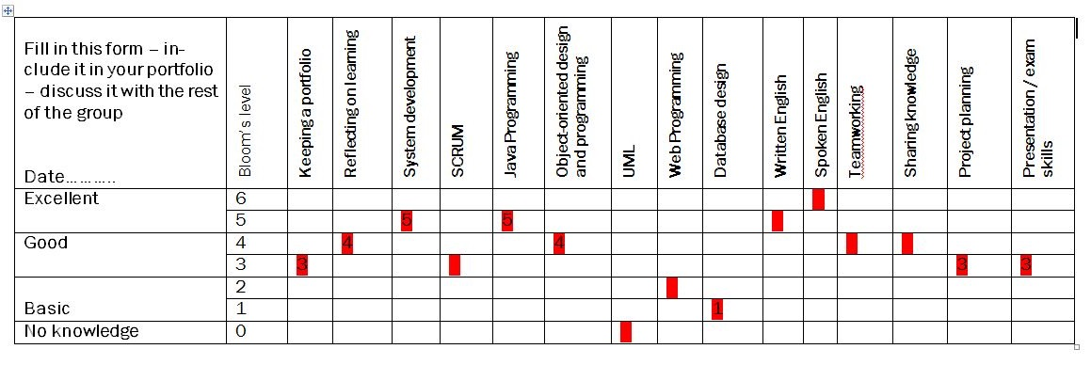

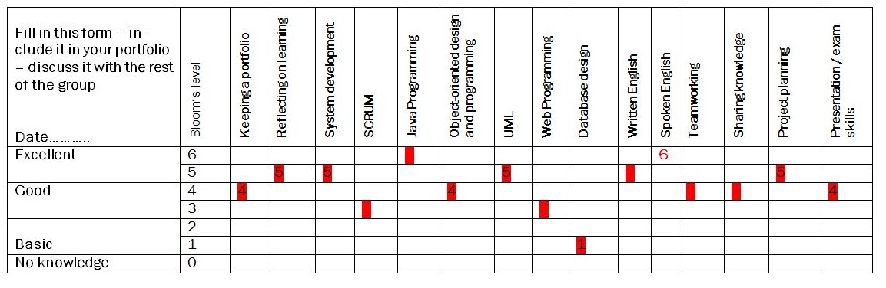

**Martin Kostadinov:**

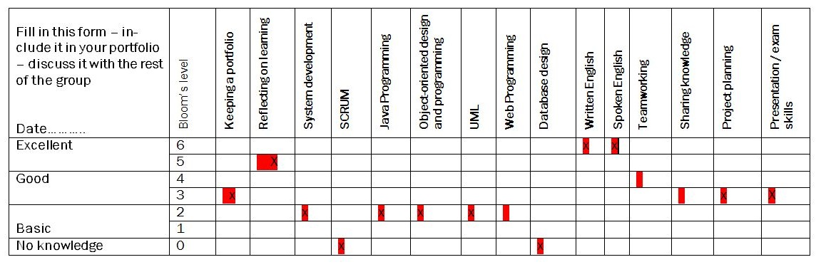

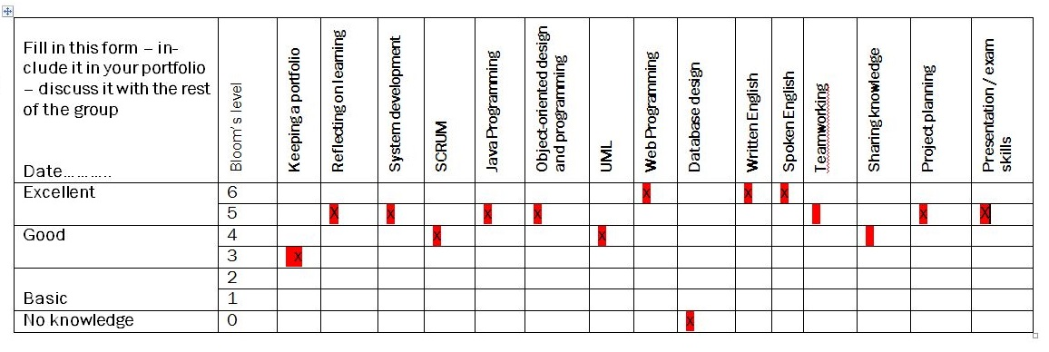

**Octavian Grozman:**

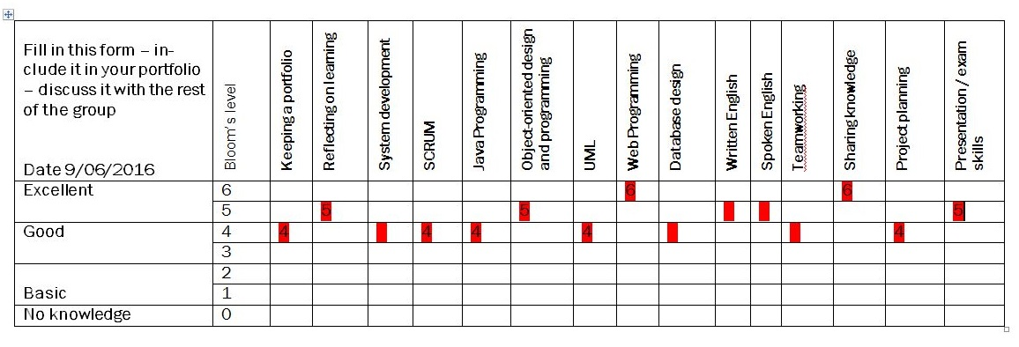

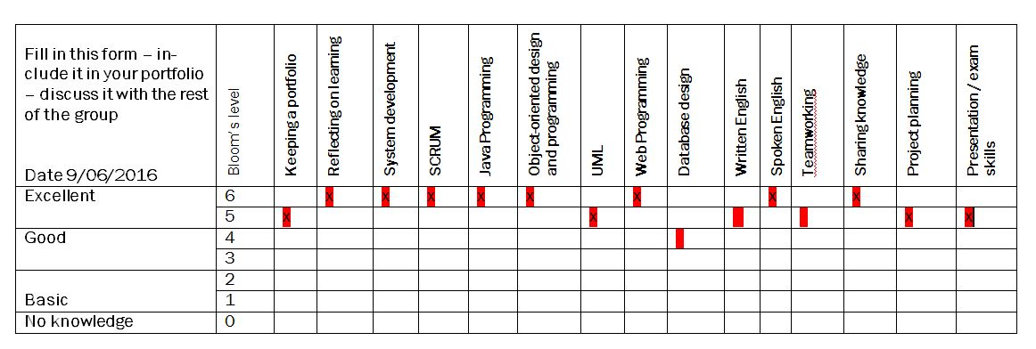

**Mihai Timotin:**

